PolytechMarseille Avril 2021
Informatique
Media Sociaux & Big Data
Mohamed Quafafou (mohamed.quafafou@univ-amu.fr)

Youtube Data Source
- Querying, Storage and Search -
Course Web site : http://wvm-srv5.luminy.univ-amu.fr/pm

We consider the first steps necessary for beginners to understand foundations and basic notions before starting the develpment of MyOutube application. You have first to register in order to get a key necessary for Youtuve API querying:
- Youtube account creation
  - https://console.developers.google.com/start?hl=FR
  - Create a project
  - Follow the procedure to get your Youtube key.

Exercise 1 - First Dev. step Querying and Storage

Let us start developing a simple function to perform the following tasks: (1) Youtube API querying, (2) Storage of the returned results in a relational database.
- Dev. App1.v1.js – Youtube Querying (without parametrs), use youtube-node
  - Install youtube-node (npm install youtube-node) in the folder of In App1.v1.js,
  - Run App1.v1.js (node app1.v1.js), remark that the query is in the code
- Dev. App1.v2.js – Youtube Querying (with parametrs)
  - Modify app1.v1.js to construct app1.v2.js, in order to consider parameters
  - Run App1.v2.js (node app1.v2.js Nicolas Sarkozy)
- Dev. app1.v3.js – Storage querying results (use mysql), use node-mysql package
  - Install xampp (creation youtube DB – table Video)
  - Install mysql: npm install mysql

Exercise 2 - Second Dev. step Search application

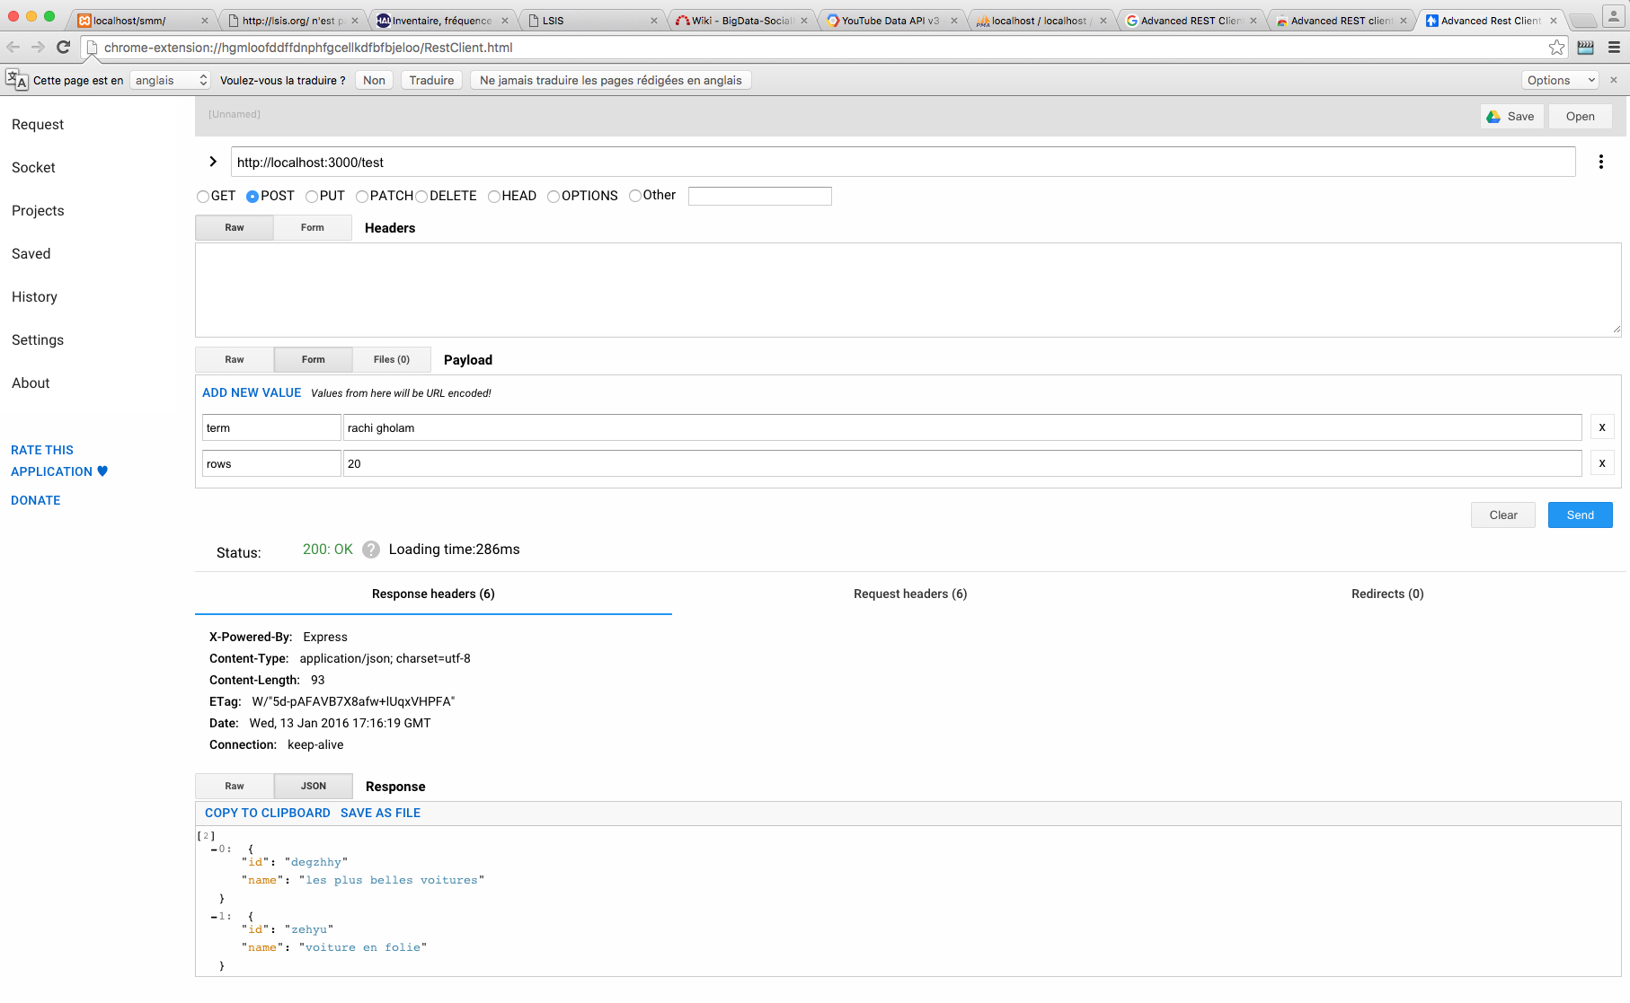
Now, us now use the Youtube search method instead of the previous test method:
- Exposition of the test method (app1.v3.js) that returns Fake object
  - Install Advanced REST Client application using Chrome browser
  - Install package express (npm install express)
  - Start the server using app2.v1.js (node app2.v1.js)
  - Use the test method using Advanced REST Client application (See Figure 1.)

Figure 1. app2.v1.js returns a Fake object

Remark: we have not used neither the sent parameters nor the returned results! To deal with this problem, you have to rewrite consequently app2.v1.js, which became app2.v2.js, than, expose and use it with Advanced REST Client application:
- Run app2.v2.js:
  - Install the package body-parser: npm install body-parser
  - Lancer le serveur app2.v2.js : node app2.v2.js
  - Use the search method using Advanced REST Client application (See Figure 2.)
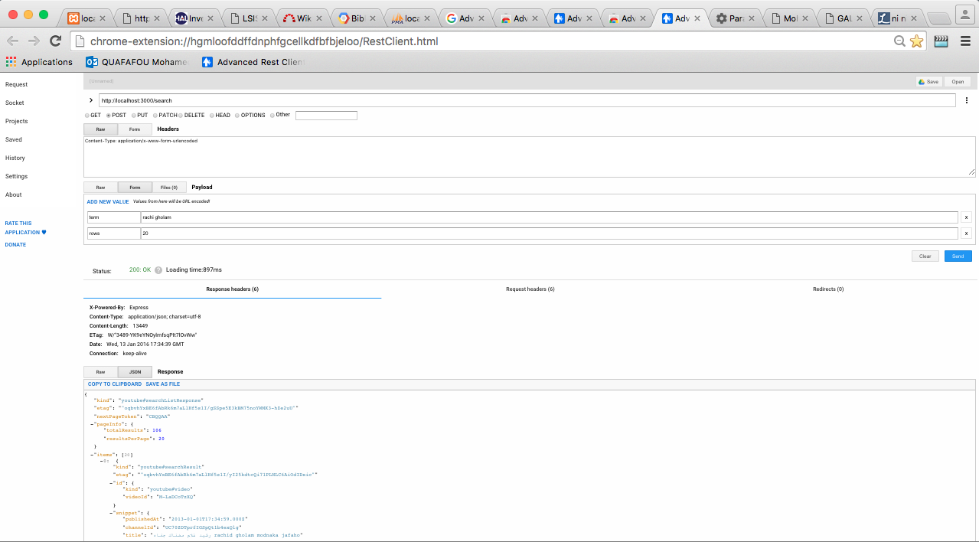
Figure 2. app2.v2.js results

Evaluation: A demo with your source code + your remarks and comment on this experiment (readme-like file). Further suggestions about this session are welcome.

